**36 Days of Type**

**Design Summary**

**1. Present final images**

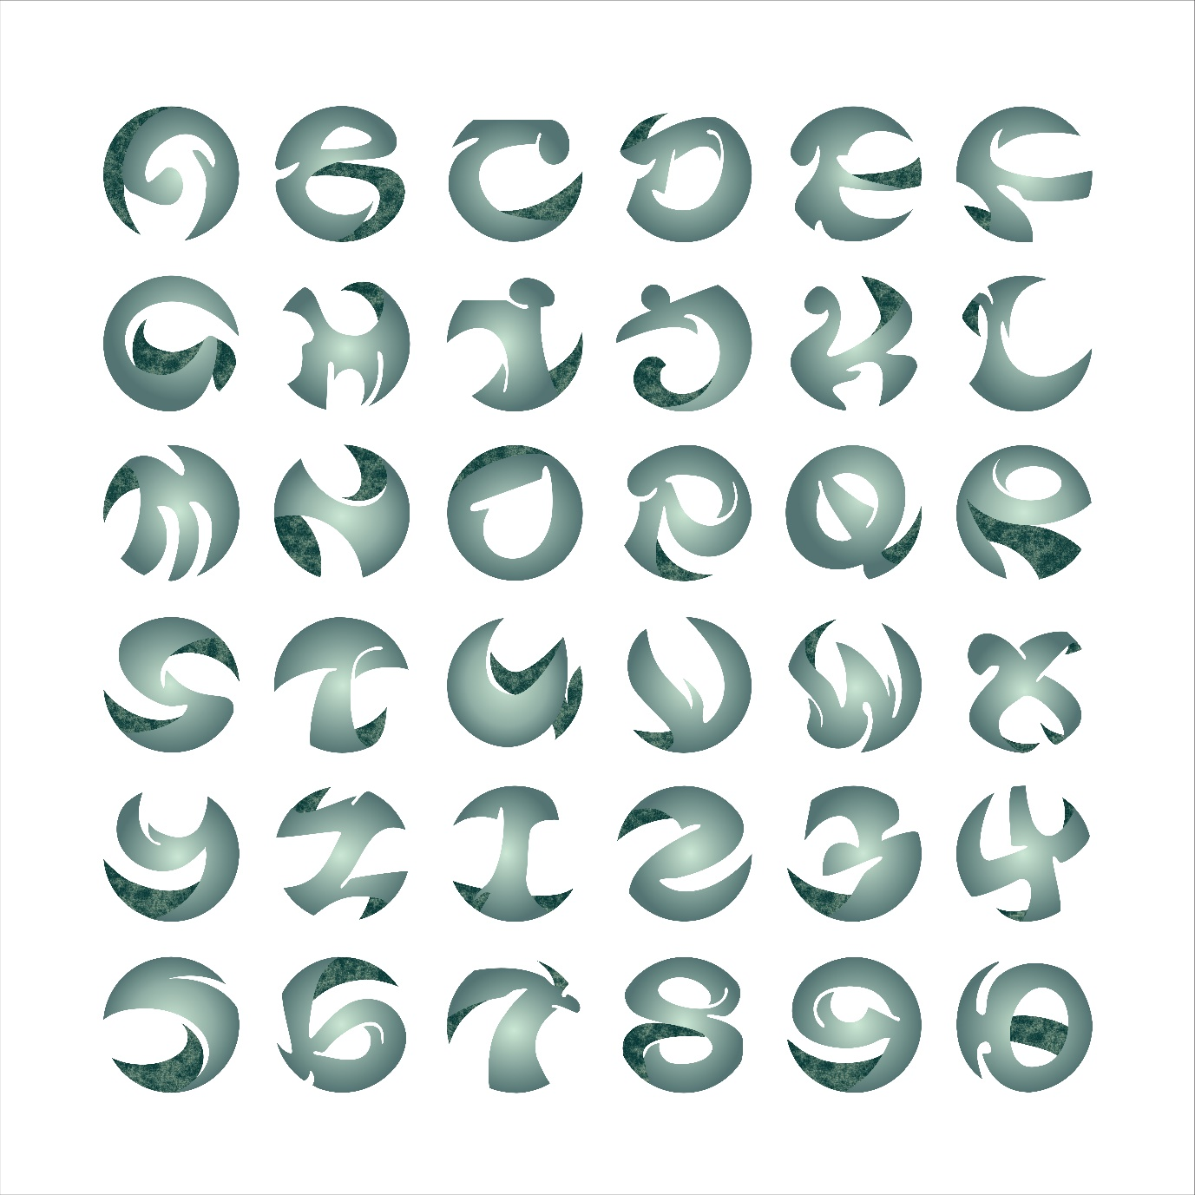



**2. Problem**

In this project, my goal was to create a creative collection for designing 36 letterforms, A-Z and0-9.

We are allowed to use raster, vector, 3D, painting, collage manipulation, and other technologies to realize letterform design ideas in the software.

**3. Solution**

My idea was to transform the shape strokes of the letters to give each letter a unique artistry that distinguishes it from block fonts while maintaining the simple readability of the letters.

Initially, I thought of borrowing the writing characteristics of traditional Chinese calligraphy strokes or imitating the characteristics of wood carving to change the strokes of these Latin letters.

After sketching and peer feedback, I settled on a sphere hollow effect as my intention.

I completed my design and production in CorelDraw and Illustrator, only using the stretch tool and fill tool, because I'd like to keep the icon graphic style of the letters in this project, different from the sophistication of the popular AI style.

**4. Process work**

Hand sketch

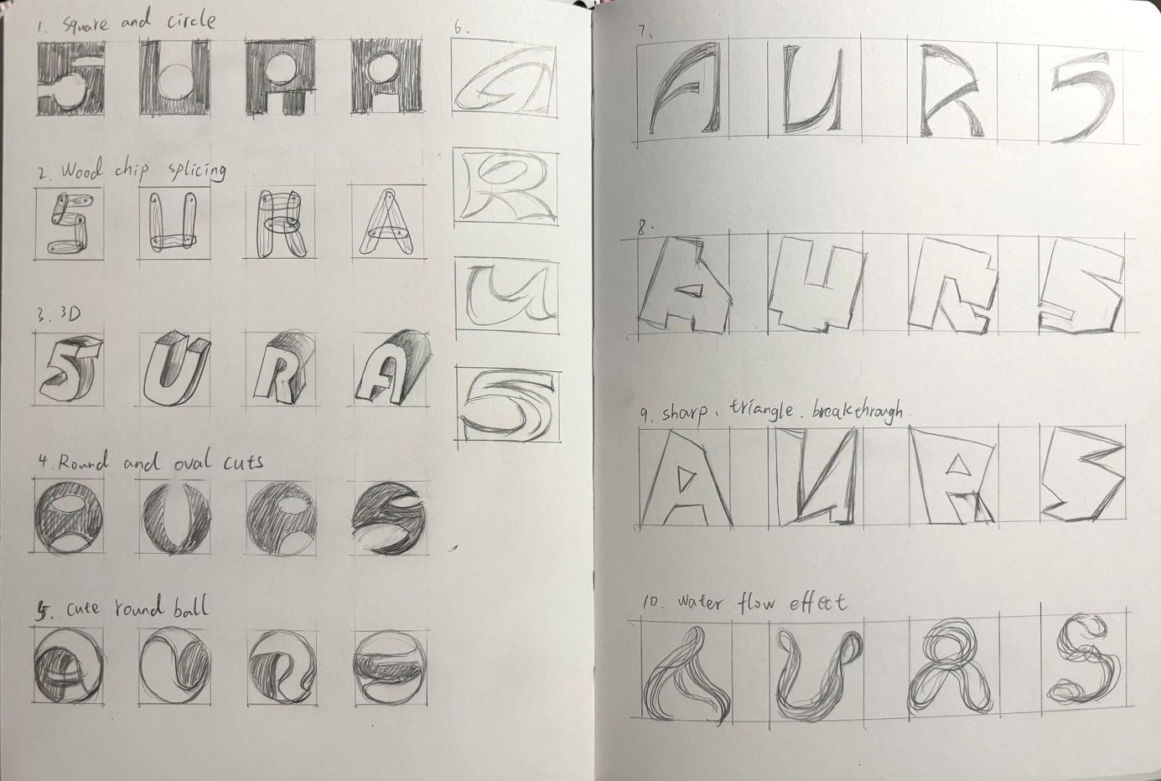

Digital Sketch

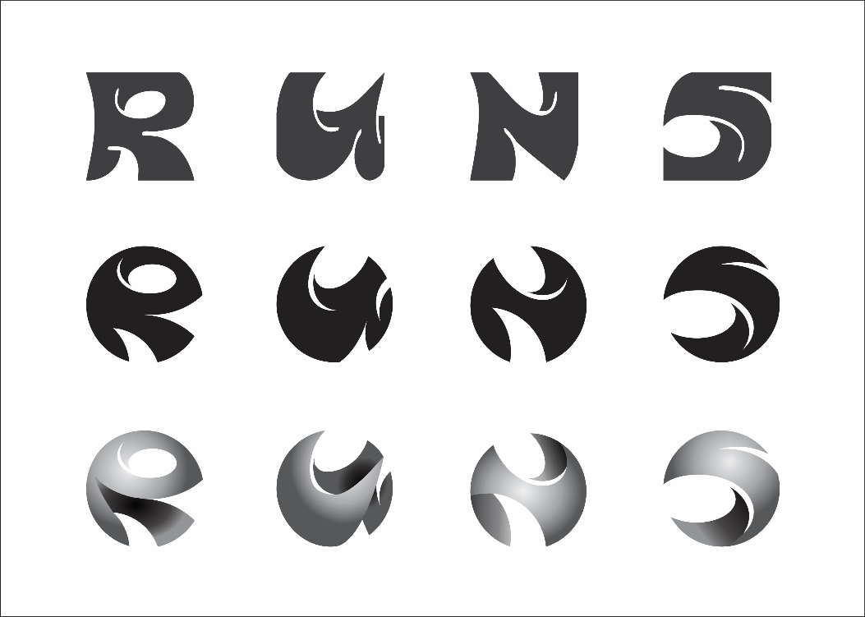

Draft for 20 characters

